**Web Technologies project support worksheet 6**

# Create View customers function (3.4 of project brief)

Copy the contents of **retrieve.php** into a new file and call it **view_customers.php**. Save it in your local work folder.

You will need to adapt the database connection info, and to make sure that the field names in your code correspond to those in your customers table.

Now run the code and make sure that it retrieves all your customers.

Once you have added headers and footers (see section 3 below) you should have something like this:

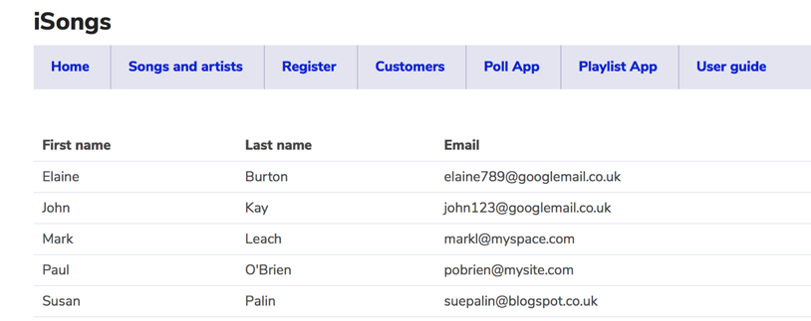

# Create View songs with artists page (3.2 of project brief)

Now create a file called **songs_artists.php** and copy the code for **view_customers.php** (created above) into it. Adapt it so that the query selects from two tables the following fields:

**Song Artist Release date Genre Price Nationality Label**

Then adapt the table structure and the array values so that they match the fields above.

Once you have added headers and footers (see section 3 below) you should have something like this:

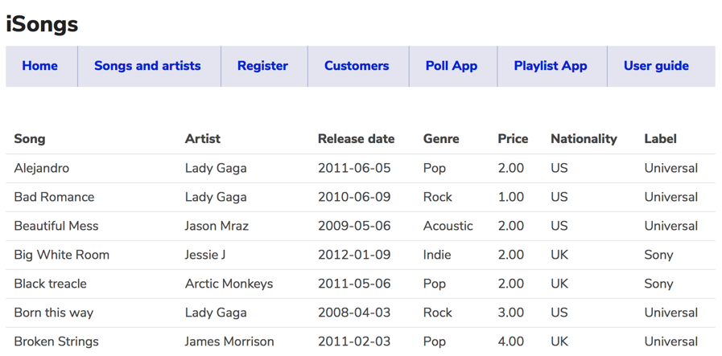

# Add headers and footers

Once you have got the code in **view_customers.php** and **songs_artists.php** to work, embed them into the navigation structure of your project using includes with references to **header.php** and a **footer.php**.

Also, make sure that it has a distinct page title created by a variable.